Task 1::
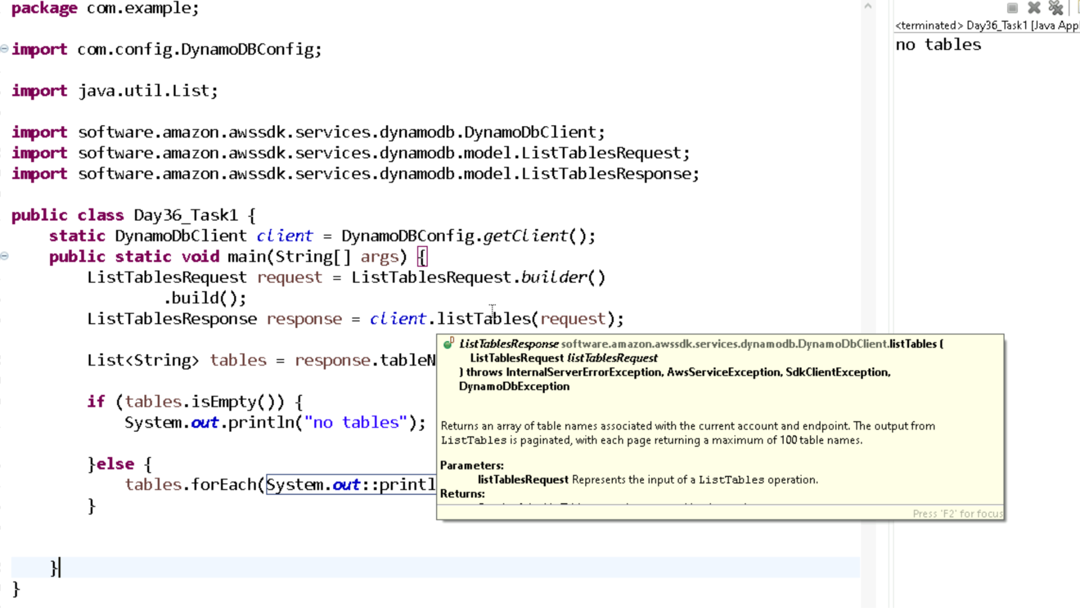
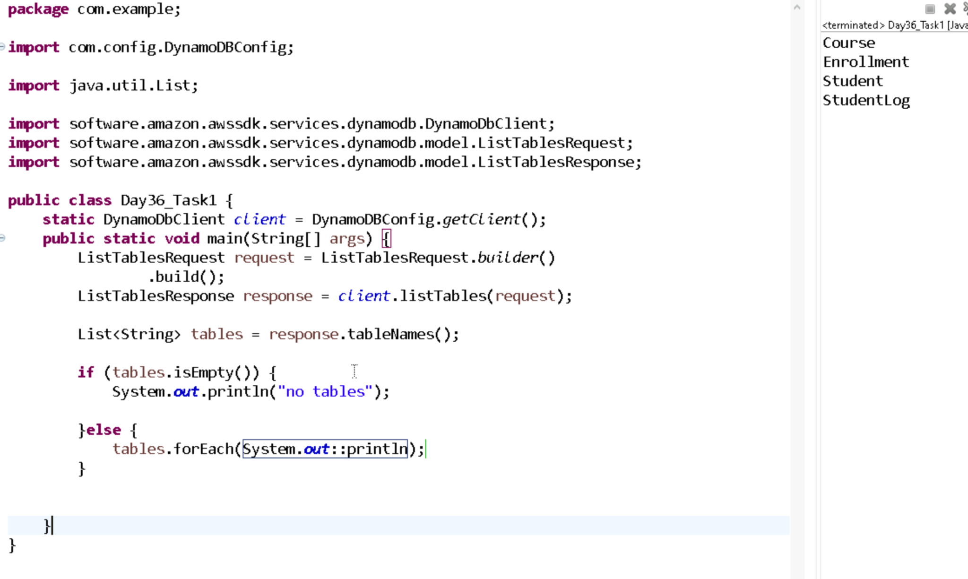

Task 3::
JUnit is a testing tool for Java. It helps check if your code is working correctly by running small tests on methods or classes.
Task4::
Latest is 5.13.x

Task5::
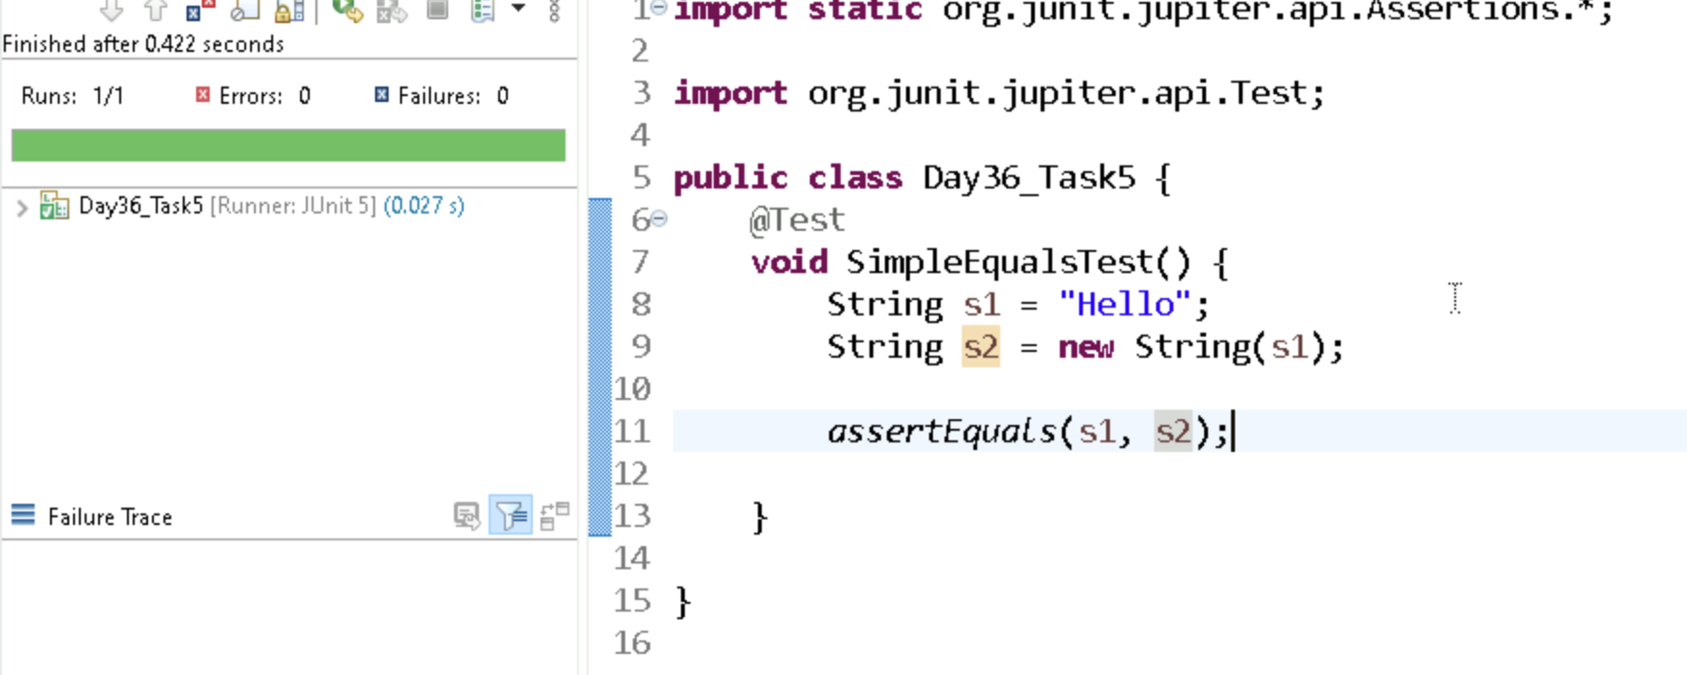

Task 6 ::
JUnit has one tag annotation: @Tag. You can give it any name (like "fast", "slow", "database") to group and filter tests.

Task 8 ::
Assertions in JUnit are statements that test expected results. They check if your program’s output matches what you thought it should be. If not, the test fails.

Task 9 ::
Assumptions in JUnit are conditions to check before running a test. If the condition is false, the test is skipped (not failed).

🔎 Common JUnit 5 Assumptions (in org.junit.jupiter.api.Assumptions)
- assumeTrue(condition) → run test only if condition is true.
- assumeFalse(condition) → run test only if condition is false.
- assumingThat(condition, () -> { ... }) → run a block of code only if condition is true.
Task 10::
Disabling test cases means marking them so they don’t run using @Disabled. We use it when a feature is not ready, a bug is pending, or the environment is not suitable for that test.
Task11::
Conditional Test Execution means running tests only if certain conditions are met.
JUnit provides special annotations for this:
- @EnabledOnOs, @DisabledOnOs
- @EnabledOnJre, @DisabledOnJre
- @EnabledIfSystemProperty, @DisabledIfSystemProperty
- @EnabledIfEnvironmentVariable, @DisabledIfEnvironmentVariable
Task12::

Automated testing means using tools to run tests on code automatically instead of checking results manually. It saves time, reduces mistakes, and makes testing repeatable.

Task 13::
Some automated testing tools and frameworks are:
- JUnit, TestNG, NUnit → for unit testing
- Selenium, Cypress, Appium → for web & mobile testing
- Cucumber → for BDD
- JMeter, Gatling → for performance testing

Task 14::
The life cycle of test automation has 6 phases:
- Planning (decide what to automate, choose tools)
- Design (prepare test cases & data)
- Development (write automation scripts)
- Execution (run the tests)
- Analysis & Reporting (check results, report defects)
- Maintenance (update scripts when app changes)

Task 17:

How many types of primary keys does DynamoDB use?

- 5
- 4
- 3
- 2

Task 18:

____ indexes enable you to query table data using a different key?

- Composite
- Secondary
- Primary

Task 19:

DynamoDB uses how many types of secondary indexes?

- 5
- 4
- 2
- 3

Task 20:

Eventually Consistent readings always return current data?

True
False

Task 21:

Which of the following data-reading action in DynamoDB receives a primary key and returns the corresponding item's attributes?

GetItem
BatchGetItem
Scan
Query

Task 22:

DynamoDB often ensures consistency across all copies in less than a second.

True
False

Task 23:

All local secondary indexes retain partition and sort keys from parent tables by default?

True
False

